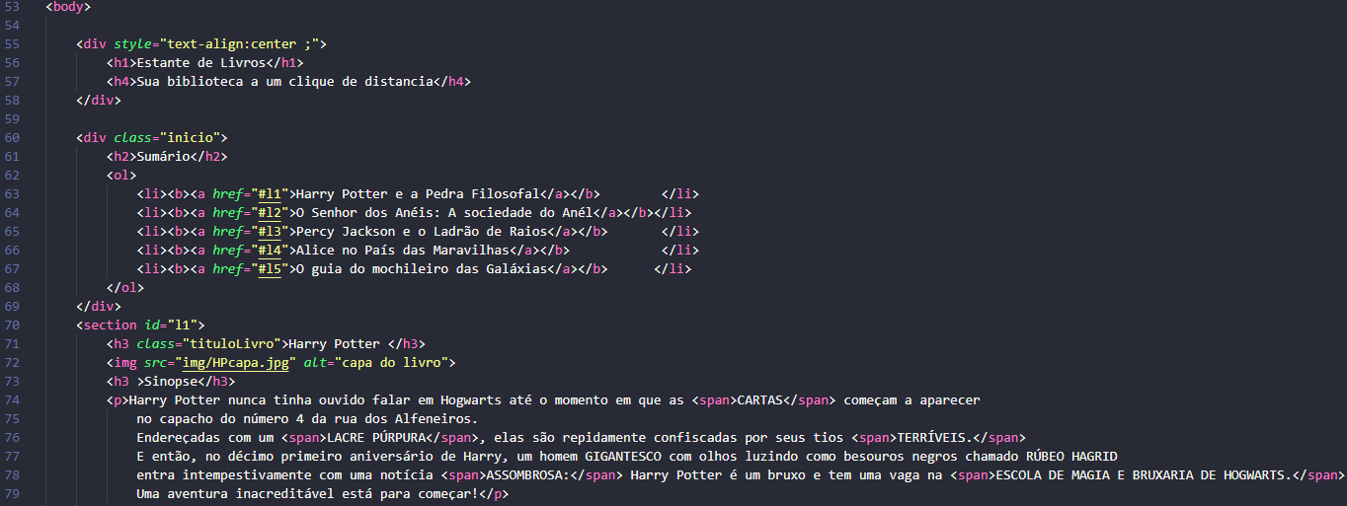

Div, h1, ol, li, selection = block level

Img, span, a, b = In line